PLEASE MAKE A COPY OF THIS DOCUMENT AND SAVE IT IN YOUR SYMPOSIUM FOLDER. YOU SHOULD DELETE THE SECTIONS THAT DO NOT APPLY TO YOU. REMEMBER, YOU’RE ONLY REQUIRED TO DO ONE OF THE STUDENT-LED RESEARCH OPTIONS.
::::::::::::::::::::::::::::::::::::::::::::::::::::::::::::::::::::::::::::::::::::::::::::::::::::::::::::::::::::::::::::::
STUDENT-LED RESEARCH PLAN
Group members:
Please write the names of your group members here (including their PARK ELA class period):
Gabriela Sedano Per.3-4, Leslie Fuerte Per.3-4, Victoria Ramírez Per. 3-4

Driving Question:
What is your driving question? Please type it out below.
How can the relationship between brand names and identity impact teenagers negatively or positively?

-------------------------------------------------

Survey
Who are you planning on surveying?
Teenagers in the school

How many people are you surveying?
50 people

How are you going to administer or give out your survey?
Through Ms. Park, she is going to pass it out to 8th and 7th grade teachers.

Write your 5-7 survey questions below. You may need to have questions on age, gender, and other background info if it applies to your data and driving question. Remember, you can have multiple choice questions, Yes/No/I don’t Know questions, or a LIKERT scale (scale of 1-5 kind of questions). Free response questions are very difficult to analyze because your data won’t be clean.
- Who would you rather be friends with? (person with brands, person without brands)
- What would they prefer? ( Brand clothing, Non-brand clothing)
- Do brands impact the way you see someone? (y/n)
- Does wearing name brands make you feel more confident? (y/n)
- Do you feel like people will like you more if you're wearing brand names? (y/n)

How does your survey relate to or help investigate the DRIVING QUESTION?
This research plan connects with our driving question because we are focusing on a certain group of people which are teenagers.

What are the limitations or possible flaws of your survey?
One limitation our survey has is that neither questions aren’t free response. One possible flaw our survey has is that one question might not be answerable right away, some people might not know if people would like them because of brands.

-------------------------------------------------

Survey - Brand names and clothing
Please take this survey and answer the questions as truthfully as possible. Do not write your name. Your response is anonymous. Thank you for your participation.

What age group do you belong to?
- 10-11
- 11-12
- 12-13
- 13-14
- 14-15

The following questions are about brand names that teens are into. Such brand names include Nike, Vans, Adidas, Supreme, Urban Outfitters, American Eagle, and Pink, among others.

Who would you rather be friends with? (circle one)

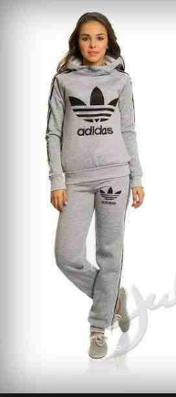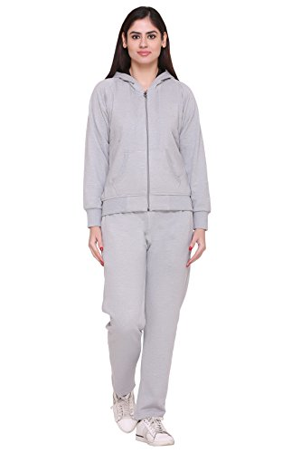
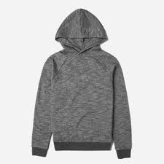
What would you prefer? (circle one)
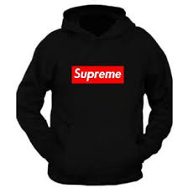f

If a person was wearing brand named clothes, how would it impact your view of that person?
- Positively
- Negatively
- It doesn’t matter
- I don’t know

Does wearing name brands make you feel more confident?
- Yes
- No
- I don’t know

Do you feel like people will have a better impression of you if you're wearing brand names?
- Yes
- No
- I don’t know

How do you generally feel about brand-named items?
- Negatively
- Positively
- Neutral
- I don’t know

