Driving Question: How can the relationship between brand names and identity impact teenagers negatively or positively?

Impact

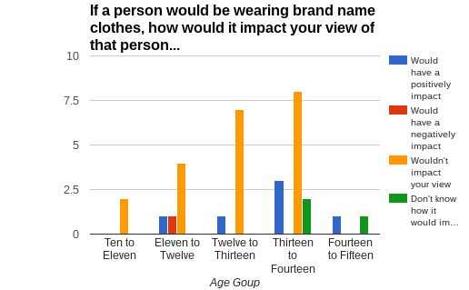

This graph above shows that 21 students would not have an impact if a person would be wearing brand name clothes while 6 students would have a positive impact. The rest is that 3 students don’t know if a person wearing brand name clothes would impact them or not and 1 student would have a negative impact. To conclude, 68% of the students would not have an impact if a person would be wearing brand name clothes.

In relationships, everything is related in some way. | - Brand names and their relationship with the consumer is very important. Companies want to have a connection with the people who will buy their clothes, so they keep purchasing clothes from that brand.  - According to Art Markman (2011), “It is easy to believe that developing the brand image and then finding ways to communicate about it are two central forces behind creating successful brands.”  - All companies want to create successful brands and to do that they need customers or everyone in general to become interested or attracted to their brand. If not attracted to the brand, the company will not be successful.

Context

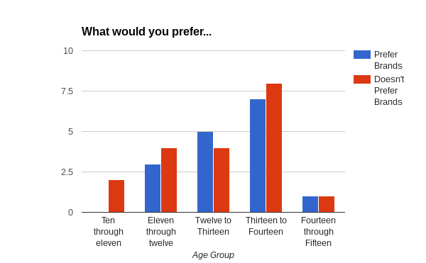

The graph above shows that 19 students would not prefer a brand name sweatshirt while 16 students would prefer a brand name sweatshirt. To conclude, 54% of the students would not prefer a brand name sweatshirt.

Relationships are powerful. | Wearing brand names or not wearing brand names can have a powerful impact.  - According to an article named Measuring the Impact of Brand Name clothing on perceptions of the wearer, by Teresa Madruga, “At first I wanted to be like the popular (and often times wealthy) students and wear brand name clothes just as they did.”  - If “popular” students were wearing brand name clothes other students would want to wear them as well to like them or to fit in. If “regular” students wear brand name clothing they would slowly become “popular” because they are wearing brand name clothes.  - According to an article named Measuring the Impact of Brand Name clothing on perceptions of the wearer, by Teresa Madruga, “People looking to shape their image could utilize results from the following study if results show that those wearing high-status clothing are perceived differently than those in low-status or no-status clothing.”  - The type of clothes people wear could influence them. The high-status also known as brand name clothes are very powerful because students are looked differently if they are not wearing “high-status” clothes or are wearing low-status clothes.

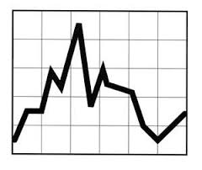

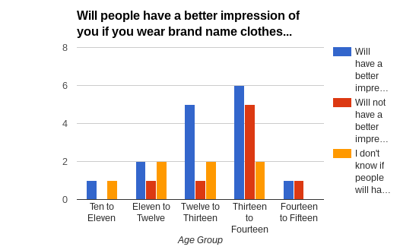

This graph above shows that 15 students will have a better impression if they were wearing brand name clothes while 8 students will not have a better impression and 7 students don’t know if they would have a better impression. To conclude, 50% of the students will have a better impression if they were wearing brand named clothes.

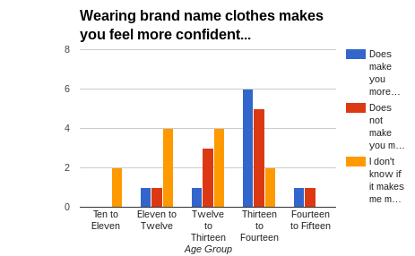

This graph above shows that 12 students don’t know if wearing brand name clothing makes them feel more confident or not while wearing brand name clothing for 10 students doesn’t make them feel more confident and for 9 students wearing brand name clothing does make them feel more confident. To conclude, 39% of the students don’t know if wearing brand name clothing makes them feel confident or not.

Relationships change over time. | - According to an article named Measuring the Impact of Brand Name clothing on perceptions of the wearer, by Teresa Madruga, “I looked at those wearing brand names as ‘better’ than those who chose not to wear brand names… By my later high school years, I felt that by wearing any brand name I was wasting my money and began to view others who wore shirts with large brand name logos as stupid for wasting their money, and often times viewed them as stuck-up. ”  - Change over time is shown because at first brand names can been seen as something positive that will help you fit in with your peers. However, as time goes by, a person’s point of view can change into a negative one due to the fact that brand names can be expensive making it a waste of money.

Changes over time

Relationships are everywhere. | Many companies use logos and catchy phrases to sell their products and these brands and tactics are seen everywhere.  - According to Art Markman (2016), “When we see other people engaging in an activity or using a particular product, it strengthens our own goal to do the same.”  - As one company prevails, the rest take notice and decide to use the same method and creates a relationships with the consumer. When the relationship with the consumers is made the companies will be successful. Therefore, we see these relationships everywhere from brands like Nike, Adidas, Pink, and much more.  - All the brand name companies are very successful because all the companies have a relationship with the consumers and these relationships are seen everywhere because the brands are everywhere.

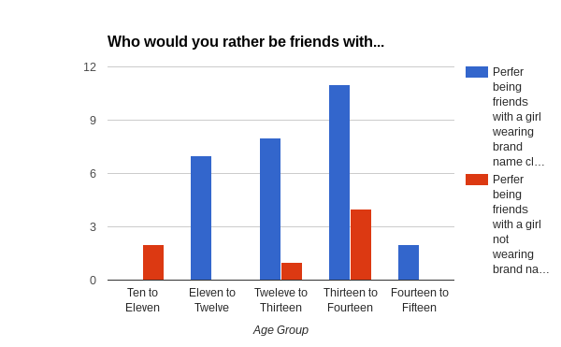 This graph above shows that 28 students would prefer being friends with a girl wearing brand name clothes while 7 students would prefer being friends with a girl not wearing brand name clothes. To conclude, 80% of the students would prefer being friends with a girl wearing brand name clothes.

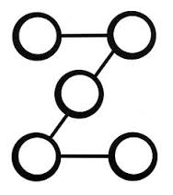Patterns

Relationships have rules. | - In order for a company to be successful, they need to create a connection with the customers or create a relationship between the brand and the consumer. By doing so, this will enable more people to continue to buy the company's products.

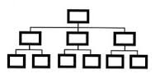
Rules

REMEMBER, when you write your findings, if you paraphrase or use direct quotes, you must cite that way we did this whole year (in the parentheses). This time, however, we’re going to try APA formatting. Look here https://owl.english.purdue.edu/owl/resource/560/01/ to find out more. APA Formatting is very similar to MLA. Instead of page numbers, you will be using dates. So, if an article was written by Sam Jones in 2007, you would do this. According to Jones (2007), blah 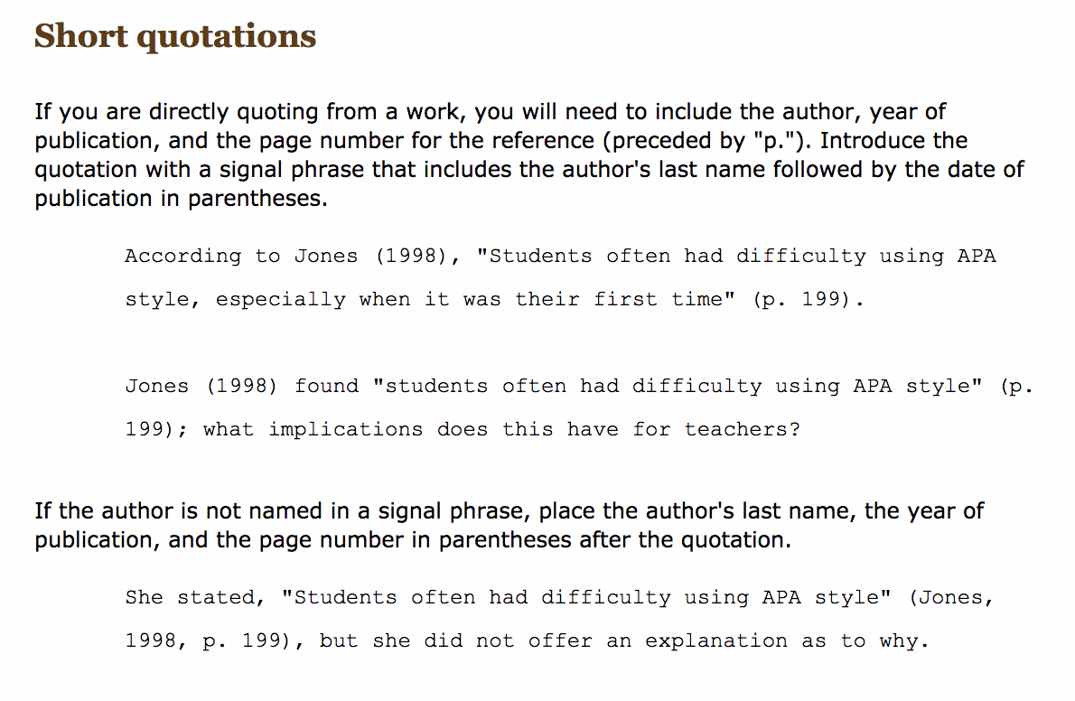

REFERENCES PAGE
Use APA formatting for this. https://owl.english.purdue.edu/owl/resource/560/01/

America, N. 0. (n.d.). Exploring the Links between Brand Name and Consumer Identity. Retrieved from http://knowledge.wharton.upenn.edu/article/exploring-the-links-between-brand
Art Markman (2016, September 24). Brand Influence Is More Than Good Communication. Retrieved from http://www.brandquarterly.com/brand-influence-good-communication-name-and-consumer-identity/
Brittany Rowe-Cernevicius ( December 20011). Brand Placement and Its Influence on the Identity of Emerging Adults. Retrieved from
https://etd.ohiolink.edu/rws_etd/document/get/bgsu1321669523/inline
Gaurav Bansal (2016, September 16). Brand name is your company's identity. Retrieved from https://yourstory.com/2016/09/brand-name-company-identity/
Staff, F. (2016, November 17). Fashion Debate: Brands vs. No Brands. Retrieved from http://faze.ca/fashion-debate-brands-vs-no-brands/
Teresa Madruga (n.d). Measuring the Impact of Brand-Name Clothing on Perceptions of the Wearer. Retrieved from https://www.csustan.edu/sites/default/files/honors/documents/journals/Stirrings/Madruga.pdf
Theodore Plantinga (2001, June 14). Not Nobody: A Brand-Name Approach to Identity. Retrieved from

https://www.calvin.edu/academic/philosophy/virtual_library/articles/plantinga_ted/not_nobody_a_brand_name_approach_to_identity.pdf

REALLY BIG IDEA CHART
You also need to either create a google drawing OR print out and hand-write the REALLY BIG IDEA CHART, with your generalizations in the columns, your driving question in the triangle, and your ending question on the bottom. This goes on the BACK of your tri-fold board. It is a rough outline of your entire project. This takes about 10 minutes to do. Please make the size of the really big idea chart below bigger.

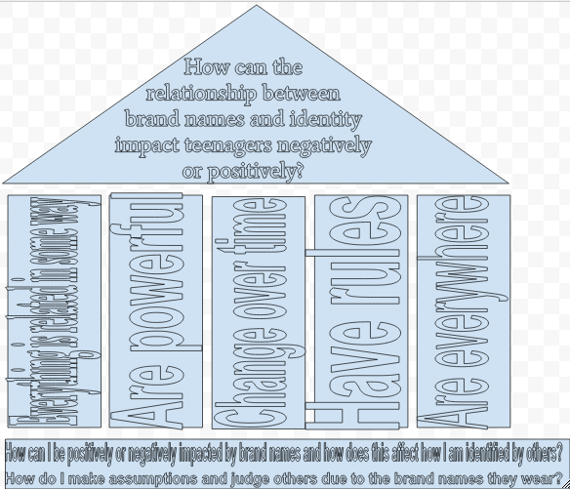

BOARD TAG
Back label - Please fill this out and glue it to the back of your tri fold board when you turn it in on May 8th in Room 310 (the media room) or Room 308 (Ms. Park’s classroom).

GLUE THIS “BOARD TAG” ON THE BACK OF YOUR BOARD!

Driving Question: How can the relationship between brand names and identity impact teenagers negatively or positively?

Names of student researchers: Victoria Ramirez, Leslie Fuerte, Gabriela Sedano

Grade level: 8 | Mentor teacher: Ms. Park
Special notes about handling and or placement or presentation space needed: None

ENDING QUESTION
Please write down the ending question in the box below. Refer to pages 93-98. You might also want to include the icon for “Unanswered questions” here too.
Ending Question - Where do I fit in?
How can I be positively or negatively impacted by brand names and how does this affect how I am identified by others? How do I make assumptions and judge others due to the brand names they wear?

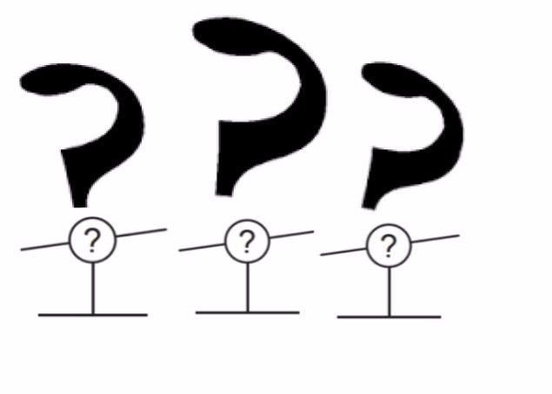

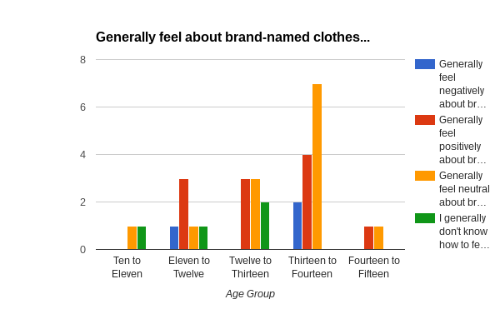

The graph above shows us that 13 students felt neutral about wearing brand name clothing and while 11 students felt positively about wearing brand name clothing. The rest is that 4 students did not know how they feel about wearing brand name clothing and 3 felt negatively about wearing brand name clothing.

